Transaction Concept
- A transaction is the basic logical unit of execution in an information system. A transaction is a sequence of operations that must be executed as a whole, taking a consistent (& correct) database state into another consistent (& correct) database state;
- A collection of actions that make consistent transformations of system states while preserving system consistency
An indivisible unit of processing
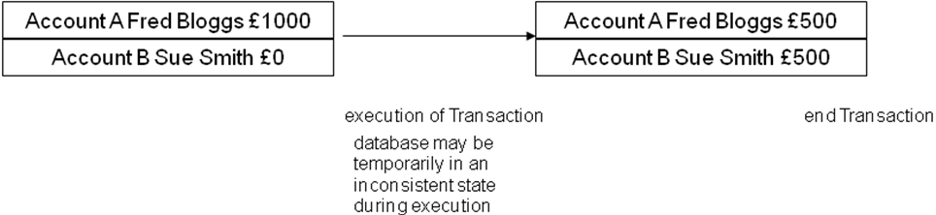

Two main issues to deal with:
- Failures of various kinds, such as hardware failures and system
Crashes.
- Concurrent execution of multiple transactions.
Desirable Properties of ACID Transactions:-
A Atomicity: a transaction is an atomic unit of processing and it is either performed entirely or not at all. This means that either all of the instructions within the transaction will be reflected in the database, or none of them will be reflected.
C Consistency Preservation: a transaction's correct execution must take the database from one correct state to another
I Isolation/Independence: the updates of a transaction must not be made visible to other transactions until it is committed (solves the temporary update problem)
D Durability (or Permanency): if a transaction changes the database and is committed, the changes must never be lost because of subsequent failure.
Read and Write Operations of a Transaction:-
- Specify read or write operations on the database items that are executed as part of a transaction
- read_item(X):
  - reads a database item named X into a program variable also named X.
1. find the address of the disk block that contains item X
2. copy that disk block into a buffer in the main memory
3. copy item X from the buffer to the program variable named
- write_item(X):
  - writes the value of program variable X into the database item named X.
1. find the address of the disk block that contains item X
2. copy that disk block into a buffer in the main memory
3. copy item X from the program variable named X into its current location in the buffer store the updated block in the buffer back to disk (this step updates the database on disk)
Transaction States:-
- For recovery purposes the system needs to keep track of when a transaction starts, terminates and commits.
- Begin_Transaction: marks the beginning of a transaction execution;
- End_Transaction: specifies that the read and write operations have ended and marks the end limit of transaction execution (but may be aborted because of concurrency control);
- Commit_Transaction: signals a successful end of the transaction. Any updates executed by the transaction can be safely committed to the database and will not be undone;
- Rollback (or Abort): signals that the transaction has ended unsuccessfully. Any changes that the transaction may have applied to the database must be undone;
- Undo: similar to ROLLBACK but it applies to a single operation rather than to a whole transaction;
- Redo: specifies that certain transaction operations must be redone to ensure that all the operations of a committed transaction have been applied successfully to the database;
Transaction execution:-
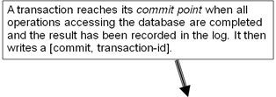
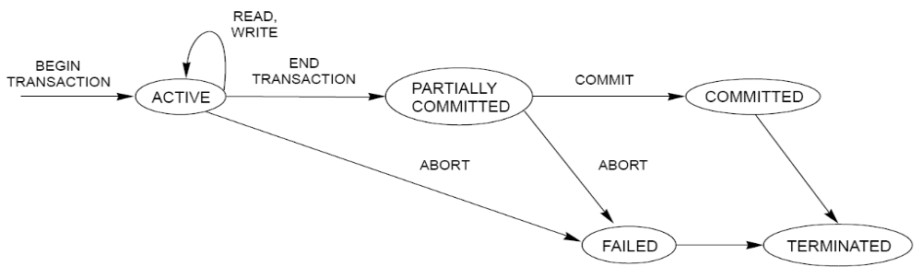
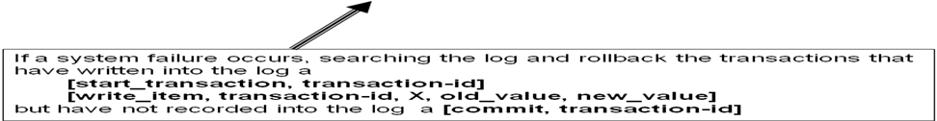

Why Concurrency control is needed:-
In a multiprogramming environment where multiple transactions can be executed simultaneously, it is highly important to control the concurrency of transactions. We have concurrency control protocols to ensure atomicity, isolation, and serializability of concurrent transactions. Concurrency control protocols can be broadly divided into two categories −
- Lock based protocols
- Time stamp based protocols

Transaction as a Concurrency Unit:-
- Transactions must be synchronized correctly to guarantee database consistency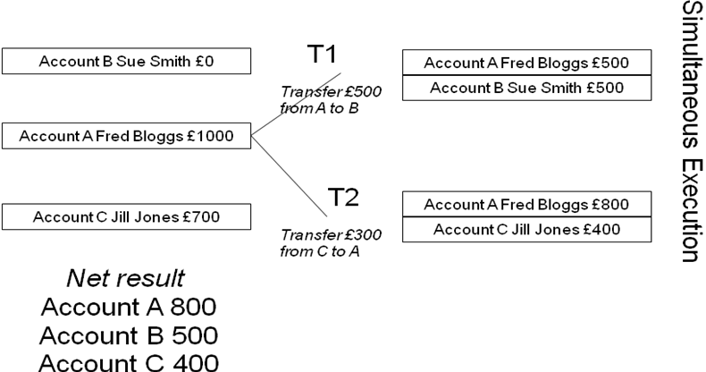
The following problems occurred while concurrent execution of transaction.
The Lost Update Problem:-
Two transactions accessing the same database item have their operations interleaved in a way that makes the database item incorrect
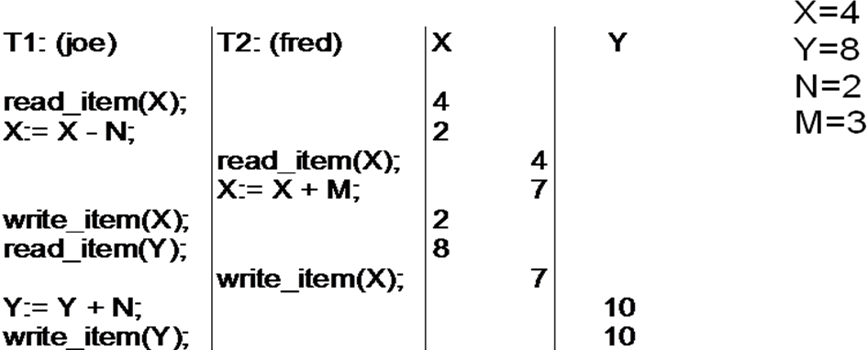
- item X has incorrect value because its update from T1 is “lost” (overwritten)
- T2 reads the value of X before T1 changes it in the database and hence the updated database value resulting from T1 is lost
Dirty Read or The Temporary Update Problem:-
- One transaction updates a database item and then the transaction fails. The updated item is accessed by another transaction before it is changed back to its original value
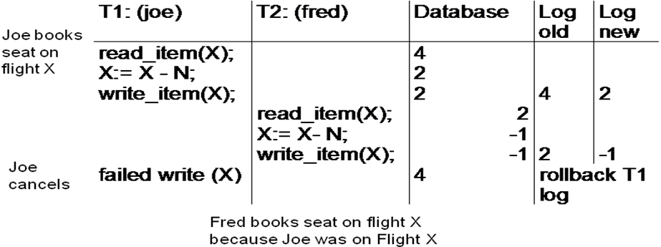
- transaction T1 fails and must change the value of X back to its old value
- meanwhile T2 has read the “temporary” incorrect value of X

The Incorrect Summary or Unrepeatable Read Problem:-
- One transaction is calculating an aggregate summary function on a number of records while other transactions are updating some of these records.
- The aggregate function may calculate some values before they are updated and others after.
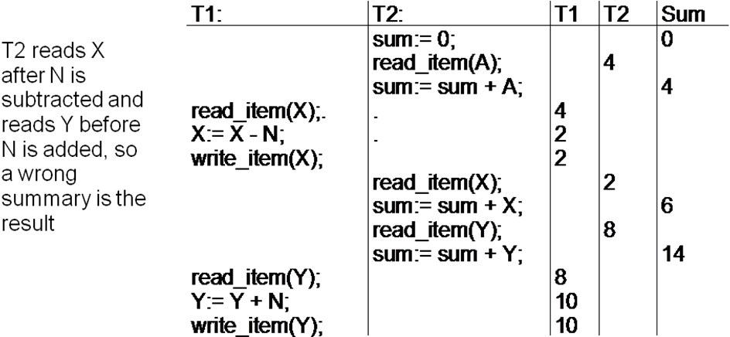

Schedules of Transactions
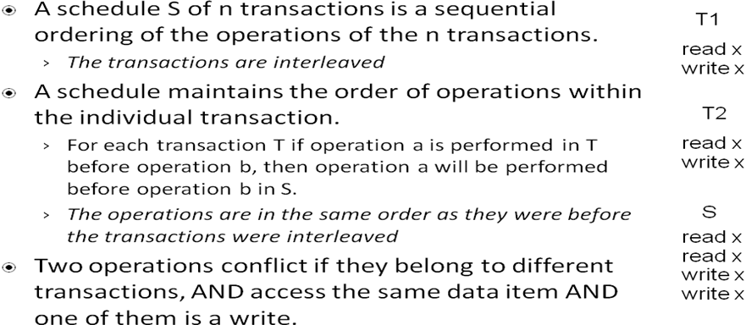
Serial and Non-serial Schedules:-
- A schedule S is serial if, for every transaction T participating in the schedule, all of T's operations are executed consecutively in the schedule; otherwise it is called non-serial.
Example of Serial Schedules
Schedule A Schedule B
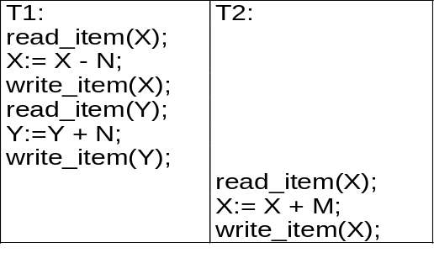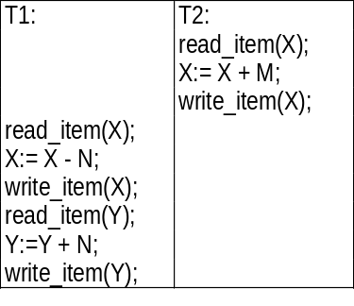

- Non-serial schedules mean that transactions are interleaved. There are many possible orders or schedules.
Example of Non-serial Schedules
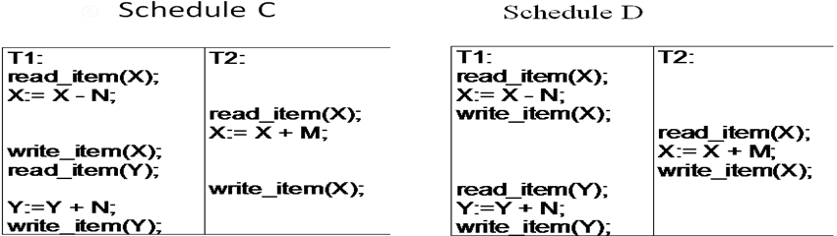

Serializability of schedules:-
Serialisability theory attempts to determine the 'correctness' of the schedules.
- A schedule S of n transactions is serializable if it is equivalent to some serial schedule of the same n transactions.
Schedule A Schedule B
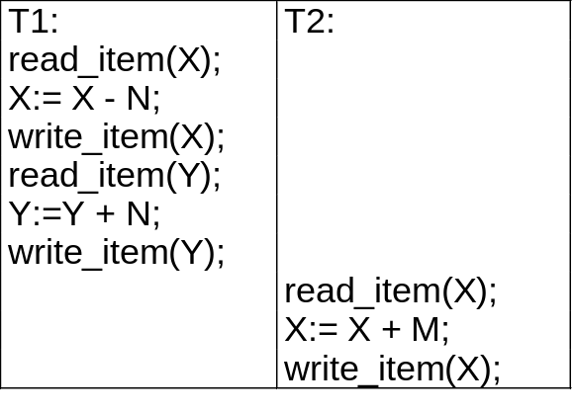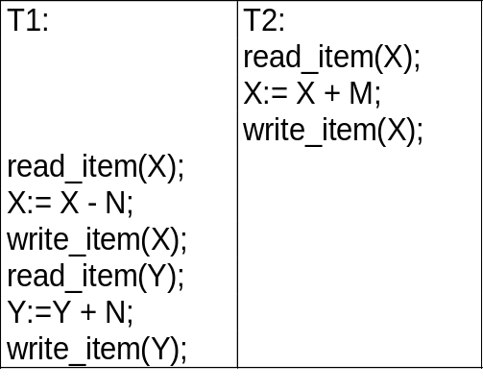

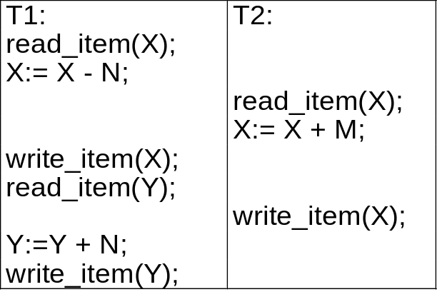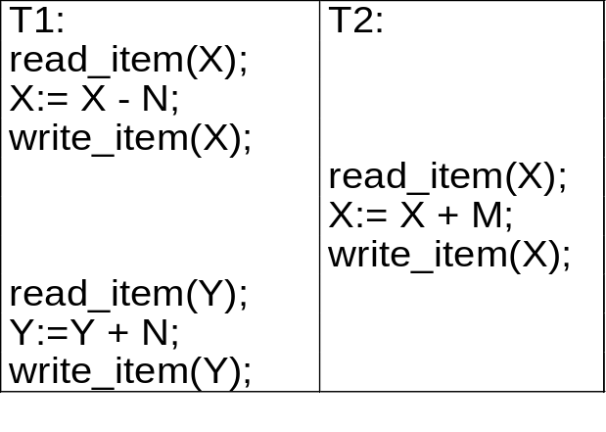Schedule C Schedule D

Equivalence Schedules
- Result Equivalence
- If two schedules produce the same result after execution, they are said to be result equivalent. They may yield the same result for some value and different results for another set of values. That's why this equivalence is not generally considered significant.
View Equivalence
- Two schedules would be view equivalence if the transactions in both the schedules perform similar actions in
- a similar manner.
- For example −
- If T reads the initial data in S1, then it also reads the initial data in S2.
- If T reads the value written by J in S1, then it also reads the value written by J in S2.
- If T performs the final write on the data value in S1, then it also performs the final write on the data value in S2.
Conflict Equivalence
- Two schedules would be conflicting if they have the following properties −
- Both belong to separate transactions.
- Both accesses the same data item.
- At least one of them is "write" operation.
- Two schedules having multiple transactions with conflicting operations are said to be conflict equivalent if and only if −
- Both the schedules contain the same set of Transactions.
- The order of conflicting pairs of operation is maintained in both the schedules.
- Note − View equivalent schedules are view serializable and conflict equivalent schedules are conflict serializable. All conflict serializable schedules are view serializable too.

Purpose of Concurrency Control
  - To enforce Isolation (through mutual exclusion) among conflicting transactions.
  - To preserve database consistency through consistency preserving execution of transactions.
  - To resolve read-write and write-write conflicts.
Example:
In concurrent execution environment if T1 conflicts with T2 over a data item A, then the existing concurrency control decides if T1 or T2 should get the A and if the other transaction is rolled-back or waits.
Locking Techniques for Concurrency Control:-
Some of the main techniques used to control concurrent execution of transactions are based on the concept of locking data items.
A Lock: is a variable associated with a data item that describes the status of the item with respect to possible operations that can applied to it.
  - One lock with each data item.
  - The lock is used to synchronize the access to the data item.
Types of Locks:-
- Binary Locks
- Multiple-mode Locks
Binary Locks
The lock can have two states (locked, unlocked) or (1,0) for simplicity.
  - It is simple but restrictive.
  - A distinct lock is associated with each database item X.
  - The current value of the lock of item X is LOCK(X).
  - If LOCK(X) is 0, item X can be accessed when required.
  - If LOCK(X) is 1, item X cannot be accessed when required.
  - Hence, binary lock enforces mutual exclusion on the item.
  - Two operations, lock_item(X) and unlock_item(X) are used with the binary locking.

- Lock_item(X)
B: if LOCK(X) = 0 (* item is unlocked *)
then LOCK(X) ß 1 (* lock the item *)
else begin
wait (until LOCK(X) = 0 and the lock manager wakes up the transaction);
go to B
end;
- Unlock_item(X)
LOCK(X) ß0; (* unlock the item*)
if any transaction are waiting
then wakeup one of the waiting transactions;
Binary Locking-
  - Lock-item and unlock_item operations are implemented as indivisible units (no interleaving should be allowed once the operation is started until it terminates or waits).
  - The wait command within the operations is implemented by putting the transaction on a waiting queue for item X until the item is unlocked.
  - A binary lock is simple to be implemented by representing the lock as record of the form <data item name, lock,locking-transaction> + a queue for waiting transactions for the data item X.
  - The records of the currently locked items are maintained in a lock table.
  - Items not in the lock table are considered unlocked.
  - DBMS has a lock manager subsystem to keep track of locks.
In binary locking, every transaction must follow the following rules:
  - A transaction T must issue lock_item(X) before any read_item(X) or write_item(X) performed in T.
  - A transaction T must issue unlock_item(X) after all read_item(X) and write_item(X) performed in T.
  - A transaction T will not issue a lock_item(X) if it already holds the lock on item X.
  - A transaction T will not issue an unlock_item(X) unless it already holds the lock on item X.
  - The rules can be forced by the lock manager module of the DBMS.
  - Thus, at most one transaction can hold the lock on an item which leads to no two
transactions can accessed the same item concurrently.

Shared/Exclusive Locking-
- It is called Shared/Exclusive or Read/Write locking.
- It is a multiple-mode lock.
- The lock has three values:
  - read_locked (shared lock): the item is locked for read purpose and can be shared for reading by another transaction.
  - write_locked (exclusive lock): the item is locked for write purpose and cannot be accessed by another transaction.
  - unlocked: the item is unlocked and can be accessed by any transaction.
Three operations are used with the Read/Write locks, read_lock(X), write_lock(X) and unlock(X).
Read_lock(X):
B: if LOCK(X) = “unlocked“
then begin
LOCK(X) ß “read_locked“;
no_of_reads(X) ß 1
end
else if LOCK(X) = “read_locked“
then no_of_reads(X) ß no_of_reads(X) + 1
else begin
wait (until LOCK(X) = “unlocked“ and
the lock manager wakes up the transaction);
go to B
end;
write_lock(X):
B: if LOCK(X) = “unlocked“
then LOCK(X) ß “write_locked“;
else begin
wait (until LOCK(X) = “unlocked“ and
the lock manager wakes up the transaction);
go to B
end;

unlocked(X):
B: if LOCK(X) = “write_locked“
then begin
LOCK(X) ß “unlocked“;
wakeup one of the waiting transaction, if any
end
else if LOCK(X) = “read_locked“
then begin
no_of_reads(X) ß no_of_reads(X) – 1;
if no_of_reads(X) = 0
then begin
LOCK(X) = “unlocked“;
wakeup one of the waiting transaction, if any
end
end;
In R/W locking the system must follow these rules:
- A transaction T must issue read_lock(X) or write_lock(X) before any read_item(X) performed in T.
- A transaction T must issue write_lock(X) before any write_item(X) performed in T.
- A transaction T must issue unlock(X) after all read_item(X) and write_item(X) performed in T.
- A transaction T will not issue read_lock(X) if it already holds a read lock or write lock on item X.
- A transaction T will not issue write_lock(X) if it already holds a read lock or write lock on item X.
Conversion of locks
A Transaction is allowed under certain conditions to convert the lock from one state to another.
- Upgrading:
  - Convert the lock from shared to exclusive by issuing write_lock(X) after its read_lock(X).
  - The transaction must be the only one has the read lock or it must wait.
- Downgrading:
  - Convert the lock from exclusive to shared by issuing read_lock(X) after the write_lock(X).

Concurrency control techniques:-
  - Two-Phase Locking (2PL)
  - Timestamp based ordering technique(TO)

- Two-Phase Locking (2PL)
A transaction is said to follow the 2PL protocol if all locking operations precede the first unlock operation of the transaction.
- The transaction is divided into two phases:
  - Growing or Expanding phase (first phase) - where new locks can be issued and non can be released.
2. Shrinking phase (second phase)- where existing locks can be released and no new locks can be granted
- In case of lock conversion:
  - Upgrading must be during Growing phase.
  - Degrading must be during shrinking phase.
Example:
T₁’ T₂’
read_lock(Y); read_lock(X);
read_item(Y); read_item(X);
write_lock(X); write_lock(Y);
unlock(Y); unlock(X);
read_item(X); read_item(Y);
X:=X+Y; Y:=X+Y;
write_item(X); write_item(Y);
unlock(X): unlock(Y);
2PL protocol guarantees the serializability of schedule without the need of testing it.
- 2PL limits the concurrency by early locking all items even it may not need all of them early and by delaying unlocking all items until locking all the item it needs even it may not need the locked item.
The algorithm is called the Basic 2PL and there are many variations to it.These are following:-
Conservative 2PL:
  - It is called also Static 2PL.
  - It requires a transaction to lock all the items it accesses before the transaction begins execution (by declaring its read and write sets).
  - If the transaction cannot lock any item, it must wait until lock all the items.
  - It is difficult in practice because it is not possible in most cases to get the read and write sets.
  - The conservative 2PL is a deadlock-free protocol.
  - The transaction starts as in its shrinking phase.
Strict 2PL:
  - It is the most popular variation of 2PL in practice.
  - It guarantees strict schedule.
  - It requires that a transaction T does not release any of its exclusive locks until it commits or aborts.
  - Strict 2PL is not a deadlock-free protocol.
Rigorous 2PL:
  - It is a more restrictive variation of Strict 2PL.
  - It guarantees strict schedule also.
  - It requires that a transaction T does not release any of its locks (shared or exclusive) until after it commits or aborts.
  - It is easier to be implemented than the strict 2PL.
  - The transaction is in its expanding phase until it ends.
The concurrency control subsystem of the DBMS is responsible for generating the required locks according to the locking protocol used.
Although the 2PL protocol guarantees serializability, it does not permit all possible schedules.
The use of locks can lead to two additional problems: Deadlock - Starvation

Deadlock-
Definition: Deadlock occurs when each transaction T in a set of two or more transactions is waiting for some item that is locked by some other transaction T’ in the set.
1. Deadlock Prevention Protocols-
  - Using the conservative 2PL (not practical).
  - Ordering the DB items.
  - Using the concept of transaction Timestamps.
  - No waiting Protocols (NW).
  - Cautious waiting Protocol.
I.1 Using the Conservative 2PL protocol:The protocol had been discussed and it was shown it is a deadlock-free protocol.The protocol is not practical because of the need of the predeclared read and write sets.
I.2 Ordering the DB items:
The protocol needs to order the DB items and enforce the transaction to lock its items in that order.
It is impractical because it requires that the programmer be aware of the chosen order of the items.
I.3 The concept of transaction Timestamp:
It is used to decide if the transaction involved in a deadlock situation should wait, abort or preempt another transaction.
  - The timestamp of a transaction T is TS(T) which is a unique identifier assigned to the transaction T and is based on the order in which the transaction T is started.
  - If T₁ started before T₂, then TS(T₁) < TS(T₂)
[T₁ is the older and T₂ is the younger]
  - There are two schemes to prevent deadlock which are wait-die and wound-wait.
Wait-die:
Suppose that T_{i} tries to lock X but it is not able to because X is locked by T_{j} with a conflicting lock:
The rule is:
    - If TS(T_{i}) < TS(T_{j}), then T_{i} is allowed to wait;
otherwise abort T_{i} (T_{i} dies) and restart it later with the same timestamp.
Wound-wait:
Suppose that T_{i} tries to lock X but it is not able to because X is locked by T_{j} with a conflicting lock:
The rule is:
    - If TS(T_{i}) < TS(T_{j}), then abort T_{j} (T_{i} wounds T_{j} ) and restart it later with the same timestamp; otherwise T_{i} is allowed to wait.
- The wait-die aborts Ti if it is the younger.
- The wound-wait aborts Tj if it is the younger.
Both protocols may cause some transactions to be aborted and restarted even they may never actually cause a deadlock.
1.4 No Waiting Protocol (NW):
  - If a transaction is unable to obtain a lock, it is immediately aborted and then restarted after a certain time delay without checking if a deadlock will actually occur or not.
  - The protocol can cause transactions to abort and restart needlessly.
I.5 Cautious Waiting Protocol:
  - It has been proposed to reduce the number of needless aborts/restarts.
  - Suppose that T_{i} tries to lock X but it is not able to because X is locked by T_{j} with a conflicting lock:
The rule is:
    - If T_{j} is not blocked (not waiting for some other locked item),
then T_{i} is blocked and allowed to wait;
otherwise abort T_{i}.
Deadlock Detection Protocols-
- The concept is to not enforce any restrictions on executing the transactions, but check if a deadlock actually exists.
- It is a more practical set of protocols.
- It is a beneficial if the transactions are short or the load is light (conflicts are not expected to highly exist).
Wait-for graph is a simple way to detect the state of deadlock
Wait-for Graph
- It is used to check the existing of a deadlock.
- How to build it:
  - One node for each currently executing transaction.
  - If T_{i} is waiting to lock an item X that is currently locked by T_{j}, a directed edge from T_{i} to T_{j} is created.
  - If T_{j} releases the lock of item that T_{i} was waiting for, the directed edge is dropped from the graph.
If the graph has a cycle, the state of the deadlock exists.
The system must abort some of the transactions when a deadlock had been detected. Selecting a transaction to be aborted is known as Victim Selection.
The algorithm of Victim Selection should avoid selecting transactions that have been running for a long time and that have performed many updates.

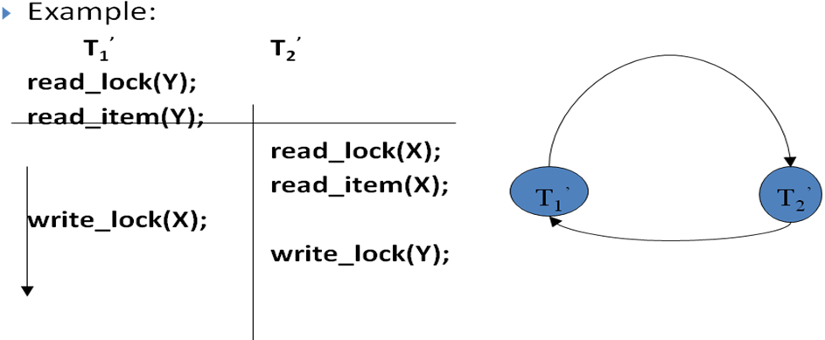
Timeouts
It is simple and practical due to its low overhead.
The idea is to have a system-defined timeout period and a mechanism to abort the transaction that waits for a period longer than the predefined timeout.
The system assumes that the transaction expired the timeout may be in a deadlock.
Starvation
The problem occurs when transaction cannot proceed for an indefinite period of time while other transactions in the system continue normally.
It may occur if the waiting scheme for locked item is unfair.
The solutions:
  - Using of a fair waiting scheme as first-come first-serve.
  - Allowing priorities for transaction but increase the priority of a transaction the longer it waits, until it eventually gets the highest priority and proceeds.
It also may occur if the Victim Selection algorithm used in deadlock detection protocol selects the same transaction as a victim repeatedly.
The solution:
The algorithm can use higher priorities for transactions that have been aborted multiple times.
Note: Wait-die and Wound-wait protocols avoid starvation.

- Timestamps Based concurrency control technique:-
Timestamp concurrency control protocols using the timestamps to order the execution of transaction for an equivalent serial schedule to guarantee serializability.
Definition: Timestamp TS(T) is a unique identifier created by the DBMS to identify the transaction.
The timestamp values are assigned in the order in which the transactions are submitted to the system.
The timestamps can be generated by using a counter that is incremented each time its value is assigned to a transaction or by using the current value of date/time value of the system clock.
It is important to note that the timestamp concurrency protocols are deadlock-free because there is no lock!
The Timestamp Ordering Algorithm (TO)
- It orders the transactions according to their timestamps.
- It guarantees serializability of schedules.
- In this algorithm, the schedule is equivalent to the particular serial order corresponding to the order of the transaction timestamps.
- The algorithm must ensure that, for each item accessed by conflicting operations in the schedule, the order in which the item is accessed does not violate the serializability order.
Timestamps values:
TO algorithm associates with each item these two values:
- Read_TS(X): which equals to TS(T), where T is the youngest transaction that has read X successfully.
- Write_TS(X): which equals to TS(T), where T is the youngest transaction that has written X successfully.

Basic Timestamp ordering(TO)
The Basic TO algorithm checks whether conflicting operations violate the timestamp ordering as follows:
- If T issues a write_item(X):
  - If (read_TS(X) > TS(T) or write_TS(X) > TS(T) )
then abort and rollback T and reject the operation
[ T will be resubmitted to the system as new transaction with new timestamp]
else execute write_item(X) and set write_TS(X) = TS(T).
- If T issues a read_item(X):
  - If write_TS(X) > TS(T)
then abort and rollback T and reject the operation
[ T will be resubmitted to the system as new transaction with new timestamp]
else execute read_item(X) and set read_TS(X) = Max(TS(T),read_TS(X)).
TO algorithm guarantees conflict serializability and deadlock-free. TO algorithm may not allow some serializable schedules (as 2PL). TO algorithm may suffer from starvation.
Strict TO algorithm
- It is a variation from the basic TO to ensure that the schedule is serializable and strict (easy for recovery).
The strict TO ensures strict schedule by the following:
At T issues read_item(X) or write_item(X):
If TS(T) > write_TS(X)
then the operation is delayed until the transaction T’ that
wrote X (TS(T’) = write_TS(X)) has committed or abort.

Thomas’s Write Rule
It is another variation for the basic TO. It does not enforce conflict serializability, but it rejects fewer write operations.
- The rule modifies the write_item(X) as follows:
  - If read_TS(X) > TS(T), then abort and rollback T and reject the operation.
else If write_TS(X) > TS(T), then do not execute the operation but continue processing.
else execute write_item(X) and set write_TS(X)=TS(T).

